Maths Problem of the Week

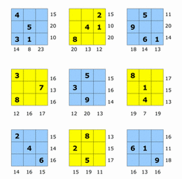
Week 9
Each puzzle box contains the numbers 1-9. Each column and each row add up to the number outside the boxes. Put the correct number in each box without repeating any number.

