Maths Problem of the Week

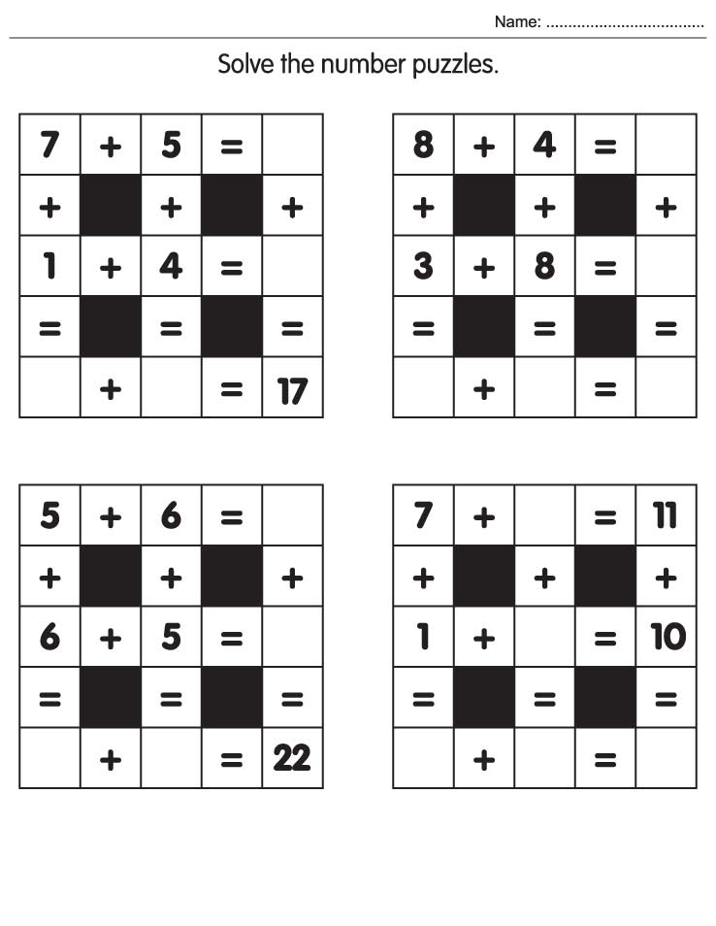
Week 8

Answers
8
21
13
9
4
11
11
11
11
11
12
23
11
12
9
8
5
12

