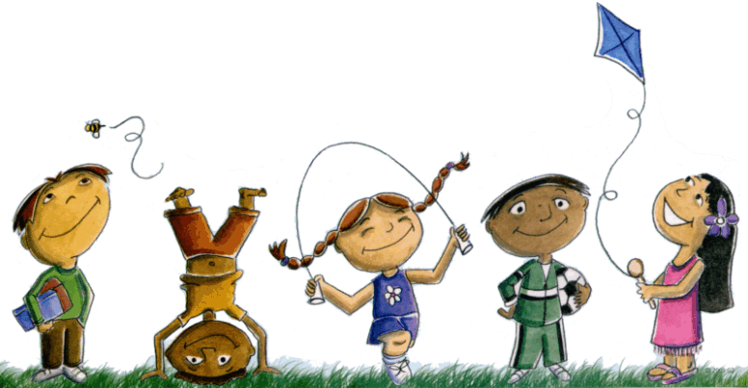

***2017 Reception***

***Term 3 Overview***

**Health and Physical Education**

* daily fitness
* Play is the Way games
* PE lessons with Ms McGrane (Thurs)
* Stability movement skills
* **Health and Well-being**
* Child Protection Curriculum
* Play is the Way program (social skills)
* Health with Ms Kapoor (Thurs)
* What’s The Buzz program
* Year 3 buddies (Wed-fortnightly)

**English**

* **Spelling:** short and long vowel sounds, initial blends, alternate diagraphs e.g. igh, ea, ay, word families e.g. ig, ot, ug

Tricky words (Oxford sight words)

* **Oral language:** weekly sharing, questioning and answering, predicting, recounts, narratives
* **Writing:** information reports, narratives, recounts, labelling and descriptive writing
* **Grammar and punctuation:** use and recognise capital/lower case letters and full stops. Begin to edit own work
* **Handwriting:** correct pencil grip and letter formation
* **Reading:** whole class shared big books, independent reading, partner reading, guided reading, buddy reading, Non-Fiction and Fiction, book week stories
* **Library borrowing** on Wednesdays

**Technologies**

* developing ICT skills
* using iPads, computers
* coding
* interactive whiteboard skills

**Mathematics**

* **Measurement and Geometry**
* use language to compare objects e.g. longer, heavier, holds more
* **Number and Algebra**
* Recognise, compare and order numbers from 1-20 and from any starting point
* A range of practical strategies to add and subtract, develop automaticity of basic number facts 1-10
* Subitise small collections of objects

**Inquiry**

* **Biological Sciences** – Living things have basic needs, including food and water
* **Big Idea**: Living things have basic needs and people can have an effect on them
* **Inquire into:**
* Living things in our environment
* Basic needs of living things
* The effects people have on living things
* Our responsibility to care for and protect living things

**The Arts and Design and Technology**

* Music & Drama with Mr Sykes (Mon)
* Visual arts, designing, creating and constructing with classroom teachers

**Science**

* **Biological Sciences** – Living things have basic needs, including food and water
* **Chemical Sciences**- Objects are made of materials that have observable properties
* Science lessons with Ms Sage (Tuesday)

**Italian**

* Italian lessons with Ms Chapman (Friday)
*  *change*

*Please note this is a working document and is subject to change ☺*  *change*