**Spelling Contract 8**

🞎 Copy your words out once and break them into their syllables

🞎 Test a friend on their words and have them test you on yours

🞎 Use the dictionary to make your own definitions for each of your words

🞎 Sort your words into nouns, adjectives, verbs

🞎 Tap your words on a partners back using the morse code sheets

🞎 Play some games of hangman with a partner using your spelling words

🞎 Write 10 sentences using your words but spell them wrong. Have a partner read through and try to find your mistakes.

**Extension**

Find as many words as possible using any combination of these 9 letters. You must use the middle letter in the word and each letter may only be used once.

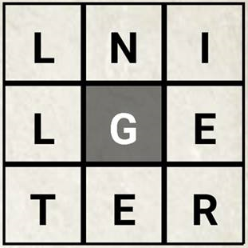

**Spelling Contract 8**

🞎 Copy your words out once and break them into their syllables

🞎 Test a friend on their words and have them test you on yours

🞎 Use the dictionary to make your own definitions for each of your words

🞎 Sort your words into nouns, adjectives, verbs

🞎 Tap your words on a partners back using the morse code sheets

🞎 Play some games of hangman with a partner using your spelling words

🞎 Write 10 sentences using your words but spell them wrong. Have a partner read through and try to find your mistakes.

**Extension**

Find as many words as possible using any combination of these 9 letters. You must use the middle letter in the word and each letter may only be used once.



**Spelling Contract 8**

🞎 Copy your words out once and break them into their syllables

🞎 Test a friend on their words and have them test you on yours

🞎 Use the dictionary to make your own definitions for each of your words

🞎 Sort your words into nouns, adjectives, verbs

🞎 Tap your words on a partners back using the morse code sheets

🞎 Play some games of hangman with a partner using your spelling words

🞎 Write 10 sentences using your words but spell them wrong. Have a partner read through and try to find your mistakes.

**Extension**

Find as many words as possible using any combination of these 9 letters. You must use the middle letter in the word and each letter may only be used once.

