**Spelling Contract 7**

🞎 Copy your words out once and break them into their syllables

🞎 Test a friend on their words and have them test you on yours

🞎 Use the dictionary to make your own definitions for each of your words

🞎 Sort your words into nouns, adjectives, verbs

🞎 Write a ten line poem using as many of your words as possible

🞎 Make up at least 5 riddles where your words are the answer

🞎 Challenge a friend to some games of spelling word noughts and crosses

**Extension**

Find as many words as possible using any combination of these 9 letters. You must use the middle letter in the word and each letter may only be used once.

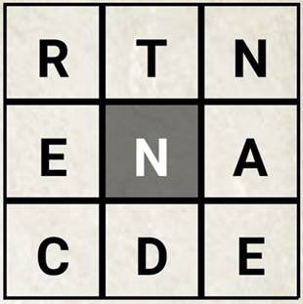

**Spelling Contract 7**

🞎 Copy your words out once and break them into their syllables

🞎 Test a friend on their words and have them test you on yours

🞎 Use the dictionary to make your own definitions for each of your words

🞎 Sort your words into nouns, adjectives, verbs

🞎 Write a ten line poem using as many of your words as possible

🞎 Make up at least 5 riddles where your words are the answer

🞎 Challenge a friend to some games of spelling word noughts and crosses

**Extension**

Find as many words as possible using any combination of these 9 letters. You must use the middle letter in the word and each letter may only be used once.



**Spelling Contract 7**

🞎 Copy your words out once and break them into their syllables

🞎 Test a friend on their words and have them test you on yours

🞎 Use the dictionary to make your own definitions for each of your words

🞎 Sort your words into nouns, adjectives, verbs

🞎 Write a ten line poem using as many of your words as possible

🞎 Make up at least 5 riddles where your words are the answer

🞎 Challenge a friend to some games of spelling word noughts and crosses

**Extension**

Find as many words as possible using any combination of these 9 letters. You must use the middle letter in the word and each letter may only be used once.

