**Spelling Contract 4**

🞎 Copy your words out once and break them into their syllables

🞎 Test a friend on their words and have them test you on yours

🞎 Use the dictionary to make your own definitions for each of your words

🞎 Sort your words into nouns, adjectives, verbs

🞎 Count the number of vowels and consonants in your words. Put this information into a table

🞎 Come up with at least 5 jokes using your words

🞎 Place your words in order from easiest to hardest to spell. Why did you order them that way?

**Extension**

Find as many words as possible using any combination of these 9 letters. You must use the middle letter in the word and each letter may only be used once.

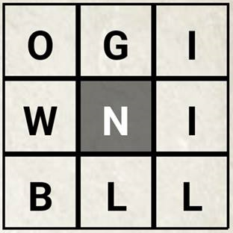

**Spelling Contract 4**

🞎 Copy your words out once and break them into their syllables

🞎 Test a friend on their words and have them test you on yours

🞎 Use the dictionary to make your own definitions for each of your words

🞎 Sort your words into nouns, adjectives, verbs

🞎 Count the number of vowels and consonants in your words. Put this information into a table

🞎 Come up with at least 5 jokes using your words

🞎 Place your words in order from easiest to hardest to spell. Why did you order them that way?

**Extension**

Find as many words as possible using any combination of these 9 letters. You must use the middle letter in the word and each letter may only be used once.



**Spelling Contract 4**

🞎 Copy your words out once and break them into their syllables

🞎 Test a friend on their words and have them test you on yours

🞎 Use the dictionary to make your own definitions for each of your words

🞎 Sort your words into nouns, adjectives, verbs

🞎 Count the number of vowels and consonants in your words. Put this information into a table

🞎 Come up with at least 5 jokes using your words

🞎 Place your words in order from easiest to hardest to spell. Why did you order them that way?

**Extension**

Find as many words as possible using any combination of these 9 letters. You must use the middle letter in the word and each letter may only be used once.

