**Spelling Contract 3**

🞎 Copy your words out once and break them into their syllables

🞎 Test a friend on their words and have them test you on yours

🞎 Use the dictionary to make your own definitions for each of your words

🞎 Sort your words into nouns, adjectives, verbs

🞎 Write a short script or conversation using as many of your words as you can

🞎 Draw a picture and hide your words in it

🞎 Write 5 detailed and complex sentences using your words.

**Extension**

Find as many words as possible using any combination of these 9 letters. You must use the middle letter in the word and each letter may only be used once.

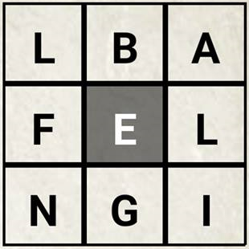

**Spelling Contract 3**

🞎 Copy your words out once and break them into their syllables

🞎 Test a friend on their words and have them test you on yours

🞎 Use the dictionary to make your own definitions for each of your words

🞎 Sort your words into nouns, adjectives, verbs

🞎 Write a short script or conversation using as many of your words as you can

🞎 Draw a picture and hide your words in it

🞎 Write 5 detailed and complex sentences using your words.

**Extension**

Find as many words as possible using any combination of these 9 letters. You must use the middle letter in the word and each letter may only be used once.



**Spelling Contract 3**

🞎 Copy your words out once and break them into their syllables

🞎 Test a friend on their words and have them test you on yours

🞎 Use the dictionary to make your own definitions for each of your words

🞎 Sort your words into nouns, adjectives, verbs

🞎 Write a short script or conversation using as many of your words as you can

🞎 Draw a picture and hide your words in it

🞎 Write 5 detailed and complex sentences using your words.

**Extension**

Find as many words as possible using any combination of these 9 letters. You must use the middle letter in the word and each letter may only be used once.

