**Spelling Contract 2**

🞎 Copy your words out once and break them into their syllables

🞎 Test a friend on their words and have them test you on yours

🞎 Use the dictionary to make your own definitions for each of your words

🞎 Sort your words into nouns, adjectives, verbs

🞎 Write a letter to someone you appreciate or are grateful for. Try to use as many of your words as possible

🞎 Write 3 of your words graffiti style

🞎 Write a 5 question quiz where your words are the answer. Test a couple of other students

**Extension**

Find as many words as possible using any combination of these 9 letters. You must use the middle letter in the word and each letter may only be used once.

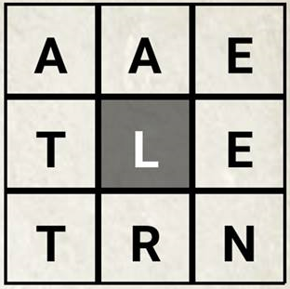

**Spelling Contract 2**

🞎 Copy your words out once and break them into their syllables

🞎 Test a friend on their words and have them test you on yours

🞎 Use the dictionary to make your own definitions for each of your words

🞎 Sort your words into nouns, adjectives, verbs

🞎 Write a letter to someone you appreciate or are grateful for. Try to use as many of your words as possible

🞎 Write 3 of your words graffiti style

🞎 Write a 5 question quiz where your words are the answer. Test a couple of other students

**Extension**

Find as many words as possible using any combination of these 9 letters. You must use the middle letter in the word and each letter may only be used once.



**Spelling Contract 2**

🞎 Copy your words out once and break them into their syllables

🞎 Test a friend on their words and have them test you on yours

🞎 Use the dictionary to make your own definitions for each of your words

🞎 Sort your words into nouns, adjectives, verbs

🞎 Write a letter to someone you appreciate or are grateful for. Try to use as many of your words as possible

🞎 Write 3 of your words graffiti style

🞎 Write a 5 question quiz where your words are the answer. Test a couple of other students

**Extension**

Find as many words as possible using any combination of these 9 letters. You must use the middle letter in the word and each letter may only be used once.

