**Spelling Contract 2**

🞎 Copy your words out once and break them into their syllables

🞎 Test a friend on their words and have them test you on yours

🞎 Use the dictionary to make your own definitions for each of your words

🞎 Sort your words into nouns, adjectives, verbs

🞎 Write a 5 question quiz you could give the class where the answers are you spelling words

🞎 Make a find a word using each of your spelling words

🞎 Try to find a rhyming word for each of your words

**Extension**

Find as many words as possible using any combination of these 9 letters. You must use the middle letter in the word and each letter may only be used once.

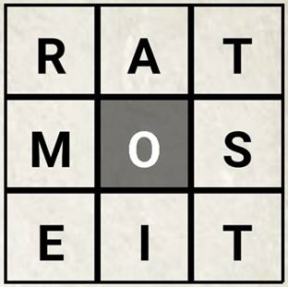

**Spelling Contract 2**

🞎 Copy your words out once and break them into their syllables

🞎 Test a friend on their words and have them test you on yours

🞎 Use the dictionary to make your own definitions for each of your words

🞎 Sort your words into nouns, adjectives, verbs

🞎 Write a 5 question quiz you could give the class where the answers are you spelling words

🞎 Make a find a word using each of your spelling words

🞎 Try to find a rhyming word for each of your words

**Extension**

Find as many words as possible using any combination of these 9 letters. You must use the middle letter in the word and each letter may only be used once.



**Spelling Contract 2**

🞎 Copy your words out once and break them into their syllables

🞎 Test a friend on their words and have them test you on yours

🞎 Use the dictionary to make your own definitions for each of your words

🞎 Sort your words into nouns, adjectives, verbs

🞎 Write a 5 question quiz you could give the class where the answers are you spelling words

🞎 Make a find a word using each of your spelling words

🞎 Try to find a rhyming word for each of your words

**Extension**

Find as many words as possible using any combination of these 9 letters. You must use the middle letter in the word and each letter may only be used once.

