**Spelling Contract 1**

🞎 Copy your words out once and break them into their syllables

🞎 Test a friend on their words and have them test you on yours

🞎 Use the dictionary to make your own definitions for each of your words

🞎 Sort your words into nouns, adjectives, verbs

🞎 Find the value of 5-10 of your words when a=$1 b=$2 c=$3 etc.

🞎 Come up with an advertisement for a product of your own invention using as many words as possible

🞎 Write your words using your opposite hand

**Extension**

Find as many words as possible using any combination of these 9 letters. You must use the middle letter in the word and each letter may only be used once.

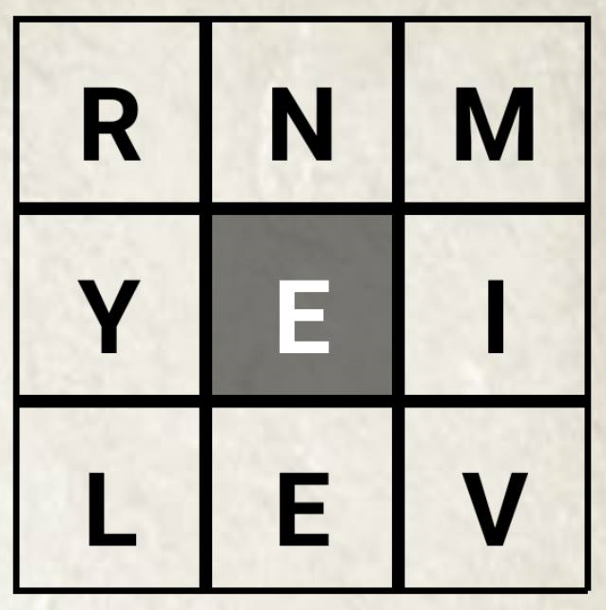

**Spelling Contract 1**

🞎 Copy your words out once and break them into their syllables

🞎 Test a friend on their words and have them test you on yours

🞎 Use the dictionary to make your own definitions for each of your words

🞎 Sort your words into nouns, adjectives, verbs

🞎 Find the value of 5-10 of your words when a=$1 b=$2 c=$3 etc.

🞎 Come up with an advertisement for a product of your own invention using as many words as possible

🞎 Write your words using your opposite hand

**Extension**

Find as many words as possible using any combination of these 9 letters. You must use the middle letter in the word and each letter may only be used once.



**Spelling Contract 1**

🞎 Copy your words out once and break them into their syllables

🞎 Test a friend on their words and have them test you on yours

🞎 Use the dictionary to make your own definitions for each of your words

🞎 Sort your words into nouns, adjectives, verbs

🞎 Find the value of 5-10 of your words when a=$1 b=$2 c=$3 etc.

🞎 Come up with an advertisement for a product of your own invention using as many words as possible

🞎 Write your words using your opposite hand

**Extension**

Find as many words as possible using any combination of these 9 letters. You must use the middle letter in the word and each letter may only be used once.

