***2017 Reception***

***Term 1 Overview***

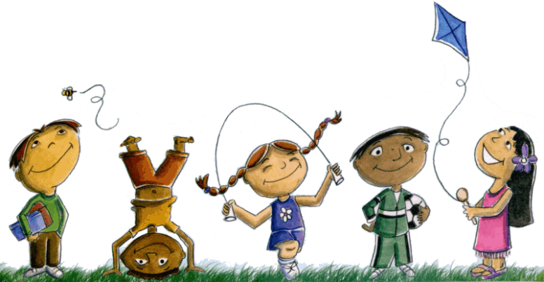

**Mathematics**

* **Number and Algebra**
* counting, writing and ordering numerals to 10
* subitising small collections of objects and recognising arrangements such as dots on a dice
* sort and classify familiar objects
* copy, continue and create patterns
* explore and use Numicon equipment
* **Measurement and Geometry**
* connect days of the week to familiar events and actions

**English**

* **Spelling:** Jolly Phonics initial sounds and blending sounds to make words
* Oxford sight words
* **Oral language:** weekly sharing, questioning and answering
* **Writing:** experimental writing and first attempts at independent recount writing
* **Grammar and punctuation:** begin to recognise and use capital letters and full stops
* **Handwriting:** correct pencil grip and letter formation
* **Reading:** whole class shared big books, independent reading, partner and group reading, buddy class shared stories
* **Library Borrowing** (Tuesday) exploring fiction and non-fiction book

**Health and Physical Education**

* Swimming - week 9
* daily fitness
* Play is the Way games
* PE lessons with Ms McGrane (Thursday)
* **Health and Well Being**
* Child Protection Curriculum
* Play is the Way program (social skills)
* Health lessons with Ms Kapor on Wednesday
* Year 3 buddies (Friday - fortnightly)

**History/Geography**

* Personal timeline, family history and structures

**Science**

* **Earth and Space sciences:**
* Daily and seasonal changes in our environment
* **Physical sciences:**
* The way objects move depending on their size and shape
* Science lessons with Ms Sage (Monday)

Italian

Italian lessons with Ms Chapman (Thursday)

*Please note this is a working document and is subject to change ☺ change*



**ICT and Media Arts**

* developing ICT skills
* iPads
* interactive whiteboard skills

**The Arts and Design and Technology**

* Drama with Mr Bolton (Friday)
* Visual arts, designing, creating and constructing with classroom teachers