Welcome to Room 9’s classroom blog!
Here you will find notices, attachments, reminder notes and photos of what has been happening in our classroom.
I can’t believe that we are now in Week 5 of Term 1. The children have settled well into classroom and school routines. I have been very impressed with the organizational skills the children are displaying already. Independence Day this Wednesday is going to be a breeze for them!
Here are a few photos of what we have been up to in our classroom. The learning has been exceptional along with the willingness to give new and exciting yet challenging activities a go!
In Maths the children have been exploring repeating patterns using a range of hands on equipment. They have been creating their own AB and AABB patterns.

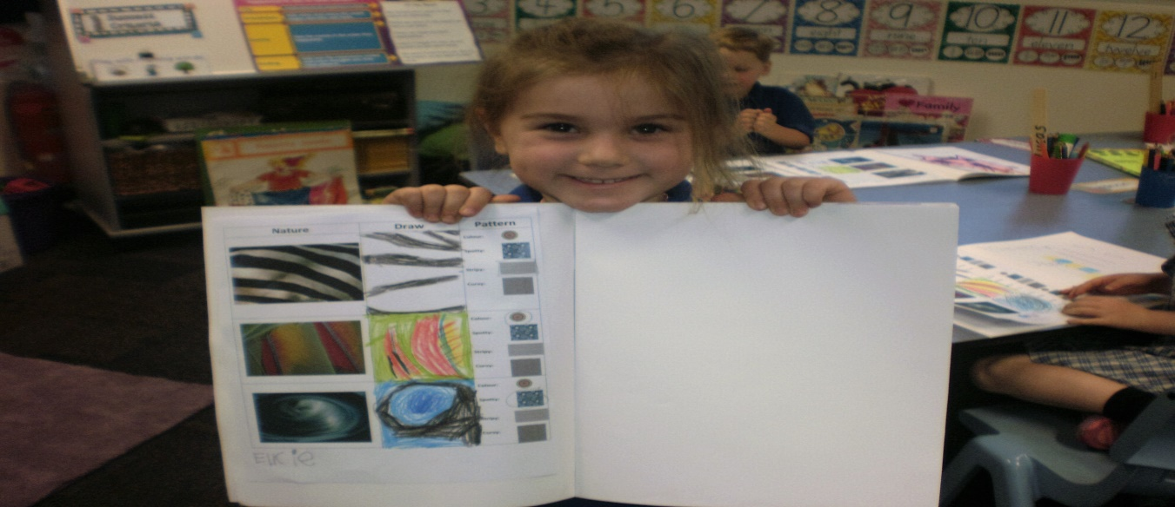

You may find that you won’t see a lot of work in the children’s Maths books but you will see photos of hands on learning posted on our classroom blog and displayed within our class
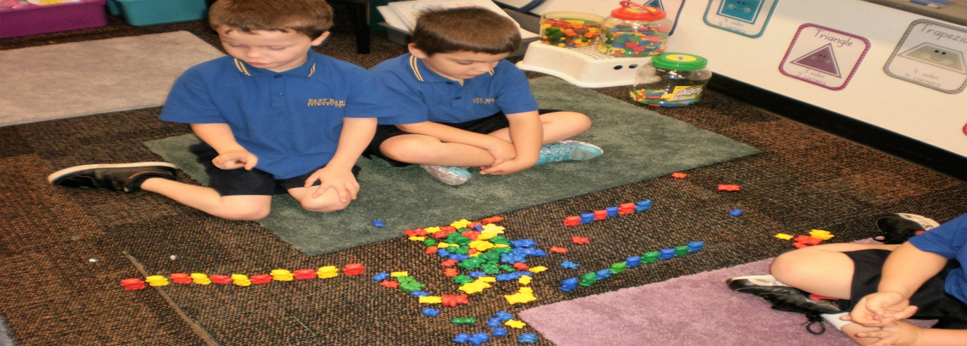
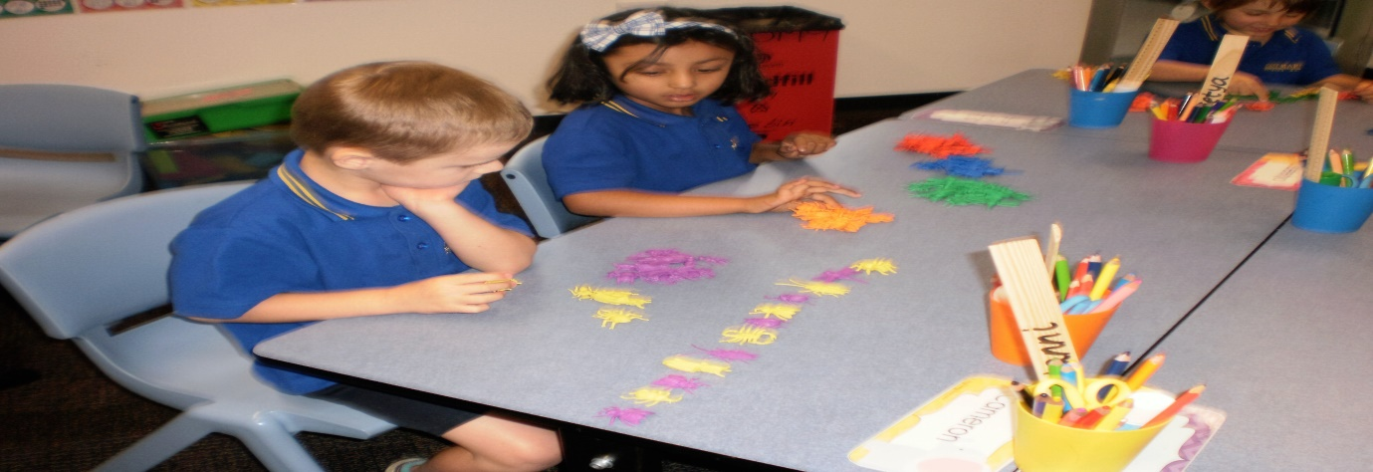

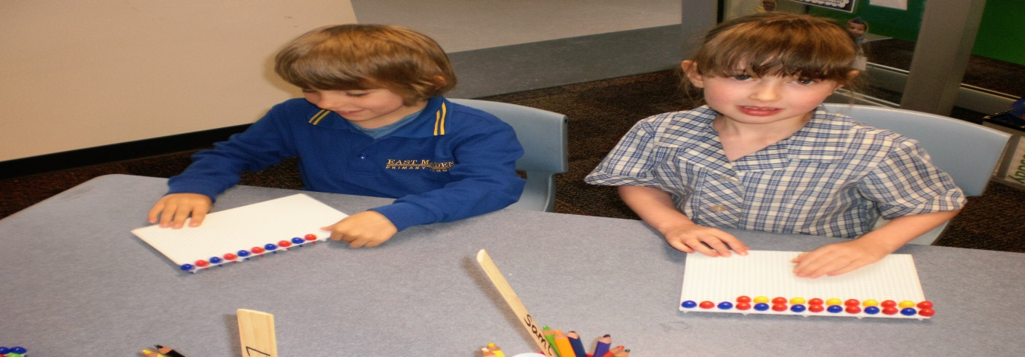
I have also attached below a term overview of what the learning will look like for all receptions in Term 1. On this overview you will see the days that the children have their specialist lessons. Note that the children’s library borrowing day will be on Wednesdays, if you could please ensure that your child brings their book back before this day so that they can borrow a new book each week.
During week 3 the children brought home their reading books. The children are encouraged to independently change their reading book every day, however, they may want to keep the same book for two nights in a row to practice fluency when reading. Reading is our number one priority for homework, remember that we want reading to be an enjoyable time for you and your child. It is important to talk about the pictures on each page before reading the words and to make personal connections with the story. The children will need your support with reading in the early stages. In your child’s yellow reading record book you will find some reading strategies to help your child with reading.
This is just a reminder that the Jolly Phonics homework is optional, we understand that your child may be tired after school/ participate in extra co-curricular activities outside of school.
Later on in the term, your child will be receiving oxford tricky words to take home. These are words that cannot be ‘sounded out’ e.g. the word ‘the’, you cannot hear the ‘t’ ‘h’ and short ‘e’ sounds, you just need to look and learn the word. There will be more information regarding the ‘tricky words’ later in the term.
If you would like to see me personally please feel free to come and make a time with me before school, after school or via email. My email address is meagan.thompson270@schools.sa.edu.au

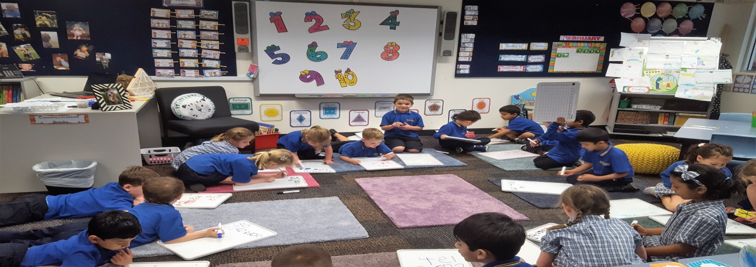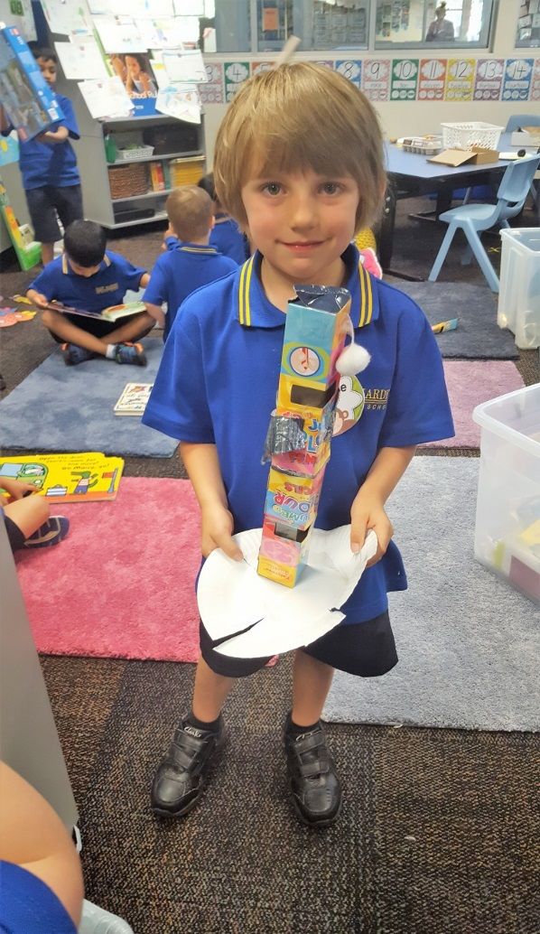
Jude made a Spaceship!
Thank you for your support.
Regards,
Meagan Thompson

